For immediate release: January 20, 2022

SPCA Florida Medical Center New Veterinarians

Lakeland, FL— Our Professional Team Has Grown! We are proud to announce in addition to our existing four Veterinarians at SPCA Florida Medical Center, that three more exceptional Doctors have joined our Medical Team. With their support, we will maintain five Veterinarians and a full team of Veterinary Technicians to serve you, five days per week.

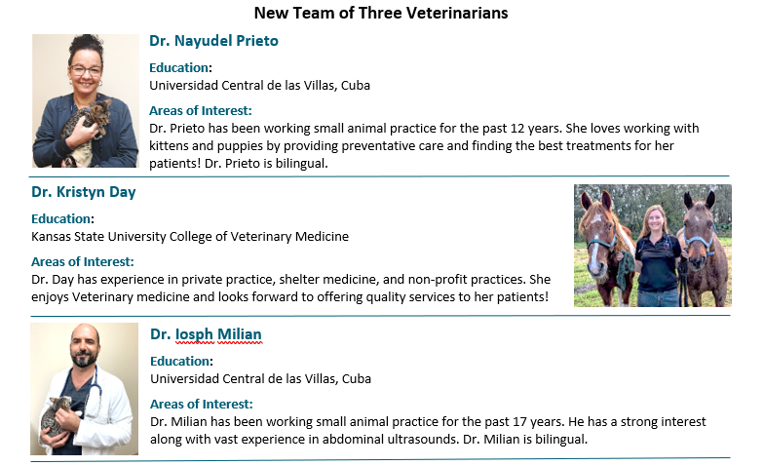
Dr. Iosph Milian
Monday – Friday: 7:30am-4pm (closed 11:30am-12pm for lunch)
Saturday and Sunday: CLOSED

For more information, visit SPCA Florida Animal Hospital at spcamedical.org.

About SPCA Florida
Founded in 1979, SPCA Florida exists to eliminate animal suffering and engage the entire community in the welfare and well-being of animals. SPCA Florida will help and heal 20,000 dogs and cats through its SPCA Florida Animal Medical Center and provide direct care for 6,500 animals through its Adoption Center this year. Ani-Meals and Food Assistance Programs, provide food and medical care for animals of homebound families and families who need supplemental food for thousands of dogs and cats each year.

